Retention of Medicare Patients: Approaches for Federally-Qualified Health Centers

Stephane Labossiere, M.S., ¹ Christopher Lindeman, MBA.²

Abstract

Objectives: The objective of this study is to address the barriers that U.S. Medicare patients face to have access to healthcare services in Federally-Qualified Health Centers (FQHCs), including quality geriatric care, for patients in their local community. Methods: We used data collected through anonymous internal and external surveys of pre-Medicare and Medicare-eligible adults ages 50 and older. Internal surveys were distributed to every patient upon check-in at the CHN Lower East Side and Washington Heights sites in New York City. Result: (Chris)
Discussion: conclusion: ( Chris)

Keywords: Medicare, Aging, FQHCs, Geriatric patients, determinants of health

¹ Johns Hopkins University, MD, USA
² Christopher Lindeman, Pittsburgh, PA, USA

BACKGROUND

Access to healthcare services for Medicare patients remains a public health issue and little is known for beneficiaries who use FQHCs (Chang, 2016). In 1989, Congress established the Federally Qualified Health Centers (FQHCs) program with the objective of supporting community health centers with primary care services delivery in low-income areas (Centers for Medicare and Medicaid, 2018). FQHCs are based on the FQHC Prospective Payment System (PPS) for medically-necessary primary health services and qualified preventive health services furnished by an FQHC professional (CMCS, 2018). By 2011, the number of FQHCs exceeded 5000 in the United States (Chang, 2016); the number of Medicare beneficiaries seen at FQHCs experienced a dramatic increase between 2001 to 2011 (from 745,000 to nearly 1.6 million) (Russel, 2019) . Older adults from low socioeconomic status (SES) often have higher difficulty tapping into much needed, life-sustaining health care. (Bennet et al. 2009; Ponce, 2006). According to the State of Aging and Health in America (SOA, 2013), the aging population of Americans aged sixty-five years or older will double during the next 25 years to about 72 million. Moreover, by 2030, older adults will account for roughly twenty percent of the U.S. population (SOA, 2013). Thus, it is important to link Medicare patients to services provided by FQHCs not only to insure that they are receiving proper treatment or referral to specialty care, but also FQHCs depend on Medicare patients for their operation and sustainability (CMS, 2013, Chang, 2016). Due to the mandated comprehensive care Medicare beneficiaries receive during their visits, FQHCs are capable of detecting and preventing health problems early because they offer a unique opportunity for patients to receive comprehensive, coordinated care in their communities (Leos, 2012). Functioning as a “one-stop shop” for health care needs, FQHCs may potentially be an ideal place for older adults to receive quality geriatric care. Although there has been a number of studies focusing on populations under age 65 ( Falik et al., 2001, McClaskey EL., 2010, Bhatia P, 2013), there is little research on the topic. There is no study of older adults who rely on FQHC services from a population-based perspective (Chang, 2016). Medicare patients suffering from multiple chronic diseases, unable to access FQHCs in their communities, or seek specialty care are some examples of public health issues older adults may face over the years. Research has shown that many Americans who survive to age 65 can expect to need and use long-term services and supports (LTSS) with an average cost of $138,000 in future LTSS costs ( HHS, 2016). Therefore, the purpose of this article is to address the barriers that Medicare patients face to have access to healthcare services in their community. Since it is crucial to understand characteristics and service use of Medicare beneficiaries who use FQHCs, this article will make recommendations for federally qualified health centers to consider when proposing, implementing, or designing geriatric care programs.

METHODOLOGY

In the United States, community health centers provide primary care for 1 in 7 Medicaid enrollees (National Association of Community Health Centers, NHCHC, 2014; Gao, 2017). However, FQHCs alone may not meet the
It is indisputable that the sample group is representative of not the general population, but a specific sub-group, namely a particularly vulnerable population of community health center patients in New York City. In comparing socioeconomic factors with the national average, we can see a stark lack of education in the sample, we can see that the population that this sample represents faces several challenges.

STATISTICS
The data consists of categorical responses to a survey questionnaire with a sample size N=124. The data was transformed from an Excel file provided by Survey Monkey into a Pandas DataFrame for analysis. The study is on a cross-sectional survey where respondents were chosen from a convenience sampling of patients at three local community health centers in New York City. The data is categorical and primary nominal, answering questions about personal experiences and dispositions.

The design of the questionnaire included categorical and ordinal response questions which were binned prior to conducting the survey, nullifying its usefulness in ordinal analysis. As the primary purpose of this survey was to aid in investigation, there is great use for designing a follow-up survey on a similar sample with new questions designed to measure the degree of effect of these concerns.

An alpha value of 0.05 was considered significant in determining similarity when compared with the general population of the United States. We performed statistical analysis using the following modules in the Python v. 3.7:
*Pandas v.1.0.3 *Numpy v.1.18.1 *Matplotlib v.3.1.3
*Seaborn v.0.10.1 *Scipy v.1.4.1 *Plotly v.4.8.1

Education (N=122)
In comparing the education of the sample with that of the US population, a new DataFrame was created from the answers to the question ‘What is your highest level of education?’ using the get_dummies function. This returned an array for each category, which we compared with the US national statistics on education from March 1995[Curry, Day. ‘Educational Attainment in the United States: March 1995’. Current Population Reports. Census Bureau p 20-489. published August 1996]. The choice of using such an old dataset was a naive attempt to help control for the increase in education across the general population, and the assumption that the sample attained its peak education before the age of 25 years. Any educational attainment after age 25 would present as unexpectedly high educational attainment among the sample group. It is worth noting that according to the 1995 data, metropolitan residents are significantly more likely (82.9% vs. 76.9%) to have at least completed high school, along with having attained a bachelor’s degree (25% vs. 14.8%) when compared with non-metrop olitan residents.

The result of comparing education levels yielded a significant difference from the national average. The sample population has a dramatically higher incidence of having not completed high school, and significantly lower incidence of education across all other levels. This is further confirmed by a one-sample t test, resulting in p<α, indicating that the sample is significantly different from the greater population.

Importance in Choice (N=123)
Considering the desires of patients is essential in providing care. The survey asks for respondents to list those concerns important to them in choosing a provider. There are 11 answers to choose from, and respondents are encouraged to check all that apply. Over 85% of respondents indicated that the location and language of the provider was important in choosing a provider. This may indicate that patients have limited access to choice in providers, as accessibility and comprehension are necessary for effective care.

Analysis
In attempting to find similarity with national averages, 1-sample t-tests were performed on incidence of seven conditions against data from various sources^{[listed below]}. While three of the results were representative of the general population, four were significantly different.

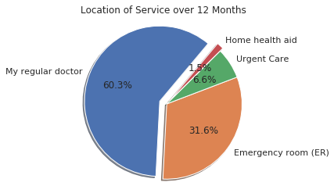

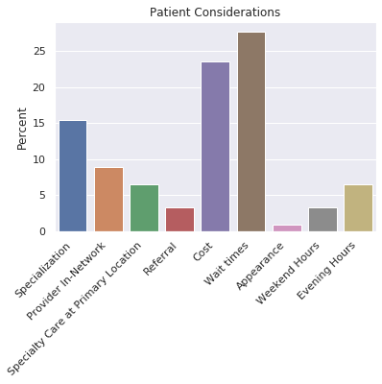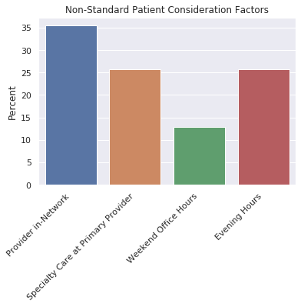

Study Population

Our internal and external surveys targeted adults aged 50-64, identifying the specific health care needs, concerns, and utilization trends of Medicare-eligible and pre-Medicare patients. Our findings resulted in practical solutions Community Healthcare Network (CHN) may consider when proposing, implementing, or designing geriatric care programs for older adults. These recommendations may also apply for other similar clinics and health centers in the United States. The recommendations serve as an opportunity to address gaps in care and identify actionable and innovative ways in which geriatric health services can be delivered.
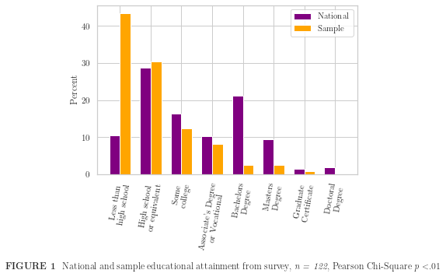
Patient Characteristics
Inclusion of the Hispanic national average shows that not only is the sample population highly uneducated compared with the national average, but it is poorly educated among the most poorly educated demographic from the sample (coincidentally the most common demographic in the sample). This is indicative of many challenges that this particular group faces and sets this group uniquely apart from the general population.

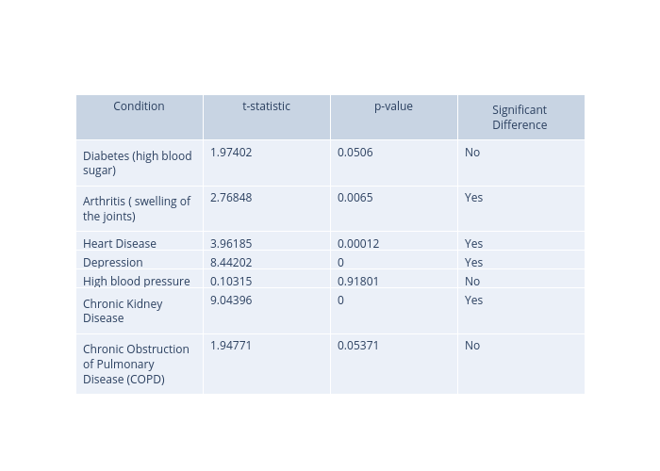
LIMITATIONS
Categorical Responses
By presenting the survey answers as categorical, this was primarily a fact-finding mission. The responses we’ve recorded give us insight into concerns within the population that warrant further investigation. Without quantitative data, establishing a concrete baseline for the efficacy of any intervention is highly limited. Additionally, binning survey answers in the collection process nullifies the power of the quantitative variables.

Uniqueness of Sample
This is a very unique population, the findings of whom will not translate directly to the greater population. The racial makeup and education attainment of this sample are not representative of a population that we have recognized. Further, the incidence of diseases varies widely when compared with national statistics. As we are focused on a specific subset of the general population, namely geriatric patients of community health centers in New York City, a more thorough analysis would include characteristics of the entire population, including race, gender, health conditions, and education levels to compare against the sample. We suspect that much of this data is available, though we have not accessed it.

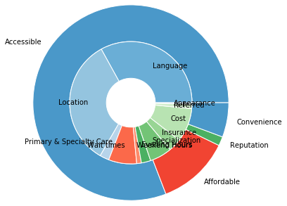

The study provides insight to unmet needs in a community health center patient cohort. This information is essential to understand service demand and increase awareness of these shortfalls. Nonetheless, limitations need to be recognized; the estimates of incidence rates come from a relatively small sample, due to limitations in design and access to participants.
That said, this preliminary data highlights some unmet needs in the community and deserves further investigation on a larger scale, preferably with access to diagnosis reports from official sources.
Comparing the sample to the national average obscures the impact of the results as the age, race, and ethnicity of the sample are not representative of the national population. Further, sampling only from community health centers in NYC means that our population for generalization must be limited to community health center patients in NYC. This is an area of importance for CHN in particular, but should not be extrapolated. The data exists to draw more useful conclusions, which are not accompanied with this study.

Recommendation:
A more well-designed questionnaire could aid in greater insights from the data, particularly regarding discrete variables. For instance, attempting to regress binned data, such as age group 55-64, leaves enough room for error that either a much larger sample would be needed, or it would be practically useless. The same goes for the number of visits respondents have made in the past year. Ideally, answers that are numeric should be obtained as a numeric answer. Clarification of some answers should be provided by offering alternative answers, such as ‘other’, as in the case of the chronic conditions question.
Answers of preference are of value in identifying problems experienced by the sample, however we cannot assume that these conditions and concerns can be applied to a wider community writ large without being able to identify the larger population more precisely.

DISCUSSION
Some questions to consider (these are just suggestions) and provide recommendations based on the overall paper:
- How can CHN address patients in need of LTSS (long-term services and supports)
- How can community health centers address these financial barriers, averaging $138,000? (see article LONG-TERM SERVICES AND SUPPORTS FOR OLDER AMERICANS: RISKS AND FINANCING)
- How can the AHRQ Quality Indicators—Guide to Prevention Quality Indicators: Hospital Admission for Ambulatory Care Sensitive Conditions be used to assist community health centers based on the data of this study ( see reference)

- State 2-3 points regarding further research as it relates to this study (Chris).
Will come from complete analysis of the information

RECOMMENDATIONS
Supporting community health centers (CHCs) and their services for patients—especially older adults—are essential for rural and inner-city communities. CHCs are often prepared to provide culturally-appropriate health care at little to no cost to patients accessing these services (Leos, 2012).

The following points are some lessons learned from the implementation of CHN Geriatric program:
- Medication Intake: Internal data show the program may help in reducing patients’ medication intake. With the assistance of the nursing staff members, patients were able to follow proper doses and avoid taking the wrong prescriptions.

- Marketing Healthcare Services: CHN and many community health centers in New York City offer a myriad of health care services and programs in addition to primary care. However, even though patients utilizing the resources had access to other multidisciplinary doctors (e.g., foot doctor, dentist, eye doctors), many did not use other services. Due to low health literacy, some patients did not understand the importance of certain services that are beneficial for their overall health and well-being. Thus, a continuum effort to mail brochures and employ other marketing strategies are important for being current and future patients.

- Glucose Machine Usage: Some patients were not aware of how to use glucose machines and/or may not be aware of that option. Some diabete patients did not know how to use glucose machines. To solve this issue at CHN, brochures and provide patients ample opportunities to use these innovative methods for monitoritation under the supervision of a health care provider.

- Documentation: Proper documents and build rapport The nurse was able to follow-up and get referrals from their health providers. Moreover, files of patients were scanned and added to the patient's file.

- Language Barrier: Hiring staff and/or ensuring this is accessible to interpretive services should be part of any new programs.

- Privacy: Assuring there is a space that ensures patients’ privacy is critical. This is important especially for open-spaces (e.g., computer labs, cafeteria, etc).

CONCLUSION

(Stephane & Chris)

ACKNOWLEDGMENT
We are grateful to several staff at Community Healthcare Network (CHN) including

We also wish to acknowledge the contributions of the survey respondents, who made this study possible through their participation in the external.

DECLARATION OF CONFLICTING INTERESTS: The authors declared no potential conflicts of interest with respect to the research, authorship, and/or publication of this article.

FUNDING: This study was funded by the Samuels grant, Grant #. The findings and conclusions presented here are those of the authors and do not necessarily represent the views of the Samuel’s

REFERENCES (20-25)

AHRQ Quality Indicators—Guide to Prevention Quality Indicators: Hospital Admission
for Ambulatory Care Sensitive Conditions. Rockville, MD: Agency for Healthcare
Research and Quality, 2001. AHRQ Pub. No. 02-R0203.

Bhatia P, Mintz S, Hecht BF, et al. Early identification of young children with hearing loss in federally qualified health centers. J Dev Behav Pediatr. 2013;34:15–21.

Centers for Medicare and Medicaid Services. Federally Qualified Health Center fact sheet. 2013. Available at: http://www.cms.gov/Outreachand-Education/Medicare-Learning-Network-MLN/MLNProducts/downloads/fqhcfactsheet.pdf. Accessed April 2, 2019.

Gao, Y. N., Nocon, R. S., Sharma, R., & Huang, E. S. (2017). What factors are associated with medicaid patients’ use of health centers?. Journal of primary care & community health, 8(3), 141-146.

Lavelle, T. A., Rose, A. J., Timbie, J. W., Setodji, C. M., Wensky, S. G., Giuriceo, K. D., … Kahn, K. L. (2018). Utilization of health care services among Medicare beneficiaries who visit
federally qualified health centers. BMC Health Services Research, 18, 41. http://doi.org/10.1186/s12913-018-2847-x
Leos, R., Kietzman, K. G., & Wallace, S. P. (2012). Opportunity Knocks for Community Health Centers: Increasing the Use of Clinical Preventive Services by Older Adults. UCLA Center for Health Policy Research.

Favreault, Melissa; Long-term services and supports for older Americans: Risks and financing research brief, 2016
Falik M, Needleman J, Wells BL, et al. Ambulatory care sensitive hospitalizations and emergency visits: experiences of Medicaid patients using federally qualified health centers. Med Care. 2001;39:551–561.
McClaskey EL. A childhood obesity program in federally qualified community health centers. J Health Care Poor Underserved. 2010;21:774–779.
National Association of Community Health Centers. Health Centers and Medicaid Fact Sheet. Bethesda, MD: National Association of Community Health Centers; 2014.
Russell L. Federally Qualified Health Centers: An Overview. http://www.chrt.org/
publication/federally-qualified-health-centers-overview/.Accessed 4 April 2019.

Sadegh-Nobari T; Opportunity Knocks for Community Health Centers: Increasing the Use of
Clinical Preventative Services by Older Adults, 2012

Potter AJ, Trivedi AN, Wright B. Younger dual-Eligibles who use federally qualified health Centers have more preventable emergency department visits, but some have fewer hospitalizations. J Prim Care Community Health. 2016 Jul 1. https://doi.org/10.1177/2150131916657081

Link: https://bmchealthservres.biomedcentral.com/articles/10.1186/s12913-018-2847-x

References (not properly cited above):

https://www.diabetesresearch.org/diabetes-statistics
https://www.cdc.gov/chronicdisease/resources/publications/factsheets/arthritis.htm
https://www.cdc.gov/nchs/fastats/heart-disease.htm
https://www.dbsalliance.org/education/depression/statistics/
https://www.google.com/url?sa=t&rct=j&q=&esrc=s&source=web&cd=&cad=rja&uact=8&ved=2ahUKEwjIwo_p9u7pAhVYmHIEHaDMDV0QFjAOegQIARAB&url=https%3A%2F%2Fmillionhearts.hhs.gov%2Fdata-reports%2Fhypertension-prevalence.html&usg=AOvVaw1BGjT0NggEl2CG5y-YK_3B
https://www.cdc.gov/kidneydisease/publications-resources/2019-national-facts.html
https://www.statista.com/statistics/1019926/copd-prevalence-among-adults-us-by-smoking-status/

APPENDIX

